23I-0544

MUHAMMAD HAMMAD

BCS-3D

COAL LAB

LAB NO 02

TASK 01:

INCLUDE Irvine32.inc

.code

main PROC

mov eax, 47

mov ebx, 39

mov ecx, 60

add eax, ebx

add eax, ecx

mov ebx, 85

mov ecx, 64

add eax, ebx

add eax, ecx

mov ebx, 54o

mov ecx, 0Ah

add eax, ebx

sub eax, ecx

call writeint

exit

main ENDP

END main

OUTPUT:  
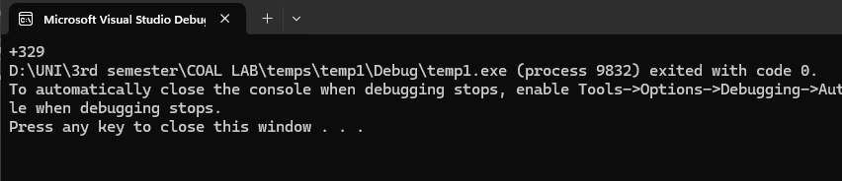

TASK 02:

INCLUDE Irvine32.inc

.data

.code

main PROC

mov eax, 30

mov ebx, 9

mov eax, 186

sub eax, ebx

add eax, 186

mov ebx, 150

sub eax, ebx

call WriteInt

call Crlf

exit

main ENDP

END main

OUTPUT:

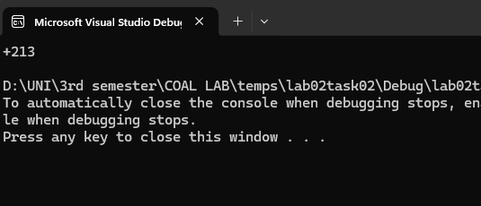

TASK 03:

INCLUDE Irvine32.inc

.code

main PROC

mov eax, 101110b

mov ebx, 50Ah

add eax, ebx

mov ecx, 6710d

add eax, ecx

mov ebx, 1010001b

add eax, ebx

mov ecx, 0Fh

add eax, ecx

call WriteInt

call Crlf

exit

main ENDP

END main

OUTPUT:

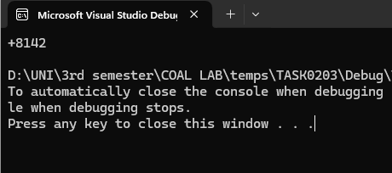

TASK 04:

INCLUDE Irvine32.inc

.code

main PROC

mov eax, 10001101b

mov ebx, 0D83h

sub eax, ebx

mov ecx, 385d

add eax, ecx

mov ebx, 10d

add eax, ebx

mov ecx, 1111101b

add eax, ecx

mov ebx, 0Eh

sub eax, ebx

mov ecx, 0Fh

add eax, ecx

call WriteInt

call Crlf

exit

main ENDP

END main

OUTPUT:

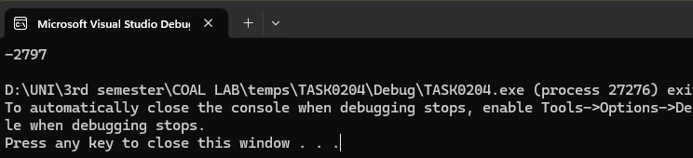

TASK 5;

INCLUDE Irvine32.inc

.code

main PROC

mov eax, 5

mov ebx, 3

mov ecx, 2

mov edx, eax

add edx, 1

add edx, ebx

sub edx, ecx

add edx, 0Ah

sub edx, 065o

add edx, 73d

call WriteInt

call Crlf

exit

main ENDP

END main

OUTPUT

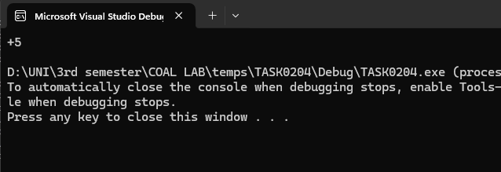

TASK 06:

INCLUDE Irvine32.inc

.code

main PROC

;assuming the values for some registers(eax=3) ; eax = 5ADh – ebx + 65o + 65d – 11110111 + 150

mov ebx, 3

mov eax, 5ADh

sub eax, ebx

mov ecx, 65o

add eax, ecx

mov ebx, 65d

add eax, ebx

mov ecx, 65d

add eax, ecx

mov ebx, 11110111

sub eax, ebx

mov ecx, 150

add eax, ecx

call WriteInt

call Crlf

exit

main ENDP

END main

OUTPUT:

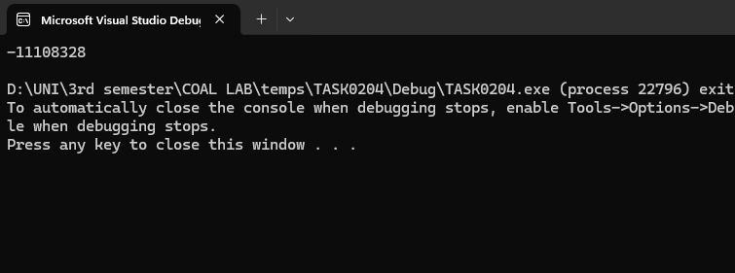

TASK 07:

INCLUDE Irvine32.inc

.code

main PROC

;ebx = 5ADh – eax + 65d + 73o – 11100101 + 7Bh

mov eax, 5ADh

mov ebx, eax

mov ecx, 65

add ebx, ecx

mov ecx, 73o

add ebx, ecx

mov ecx, 11100101b

sub ebx, ecx

mov ecx, 7Bh

add ebx, ecx

call WriteInt

call Crlf

exit

main ENDP

END main

OUTPUT:

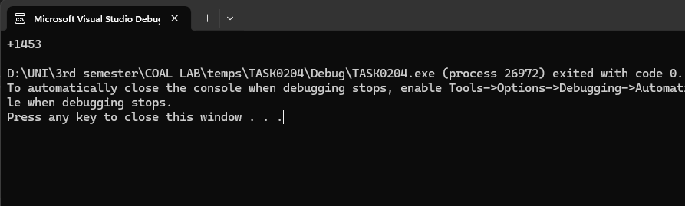

TASK 08

INCLUDE Irvine32.inc

.code

main PROC

;ecx = 110010101101b + 45h-73o + ebx -ecx + 1

mov ecx, 110010101101b

mov eax, 45h

mov ebx, 73o

add ecx, eax

sub ecx, ebx

add ecx, ebx

sub ecx, ecx

add ecx, 1

call WriteInt

call Crlf

exit

main ENDP

END main

Output

